Modeling & Evaluation

For our project, we considered three types of algorithms: logistic regression, decision trees, and random forests. The pros and cons of each algorithm are listed below:

*Logistic Regression*

Pros:

* Efficient dealing with our large dataset; LR is the fastest algorithm we used.
* Fewer parameters to be tuned which make it easier to improve.
* Low variance, so less prone to overfitting

Cons:

* Since we have a mix of multi-class and numerical features and our target variable is also multi-class, we needed to create several dummy variables
* LR requires that each data point be independent of all other data points. If observations are related to one another, then the model will tend to overweight the significance of those observations.
* LR is highly biased
* Assumes all features are linearly related to the log odds of the target variable.

*Decision Trees*

Pros:

* DT is unbiased
* Decision trees can automatically detect non-linear features and interactions between features, without having to make explicit variables
* Decision trees are fairly intuitive compared to other models

Cons:

* Prone to overfitting, especially if class sizes are small/imbalanced
* High variance
* More parameters to be tuned

*Random Forests:*

Pros:

* Almost always performs better than DT
* Reduces the variance of decision trees
* If done correctly, individual trees are independent
* RF, like DT, can handle very well high dimensional spaces as well as large number of training examples

Cons:

* Very slow to run
* Difficult to interpret as a “black box” method; an aggregation of many different decision trees
* Even more parameters than DT to be tuned

We designated the 2014-2015 data as our training set and the 2016 data as our test set. We felt this approach was the most practical because it makes more sense for test instances to occur after training instances. Given the size of our dataset, we did not feel that cross-validation was necessary. Instead, we split the training set into training and validation subsets using an 80/20 random split. Ultimately, we sought to evaluate three metrics: 1) accuracy, 2) log-loss, and 3) the Expected Value an MLB team would receive by making a series of predictions above a certain confidence threshold.

Logistic Regression and Baseline Model

To identify a heuristic baseline for accuracy, we can simply take the percentage of pitches in the dominant class (‘FF’) of our target variable. As illustrated earlier, this value is 0.3593. Our baseline model was an L2-regularized logistic regression with normalized data. The log-loss was 1.5832 and the accuracy was 0.4352.

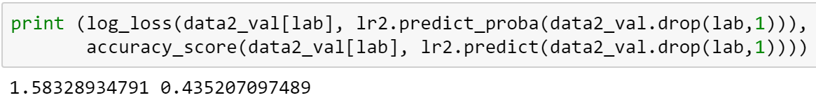

We want to improve the accuracy and decrease the Log-loss of our model. To improve the baseline model, we will try different models with several combinations of hyper parameter settings. The model with lowest log-loss and highest accuracy will be our optimal choice. First, however, we created dummy variables for multi-class features and then ran the L2-regularized logistic regression, from which we have following result: log-loss decreased to 1.56502965799 and accuracy increased to 0.437028310956.

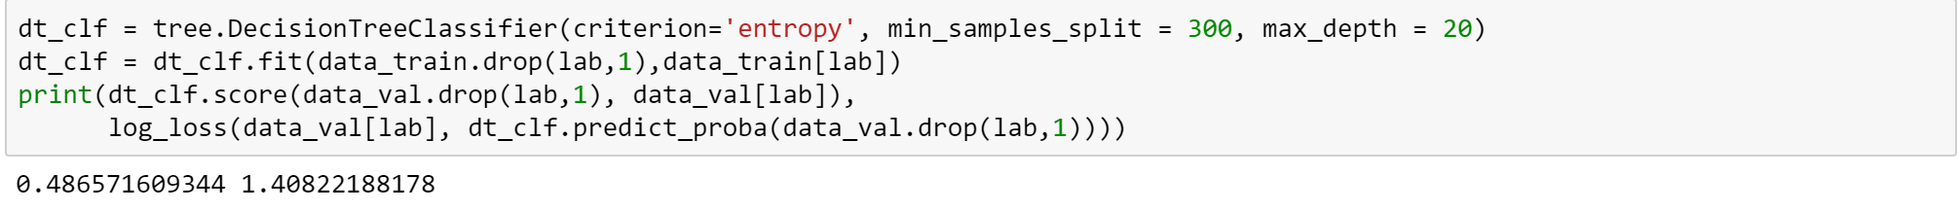

Decision Trees

In an attempt to improve upon the performance of our baseline model using Logistic Regression, we decided to run several **decision tree** instances, employing different hyper-parameters that included *maximum depth, minimum leaf size* and *minimum split size*. A cross-section of 3 values was selected for each attribute and individual trees were then fit and run for each possible permutation, yielding the following accuracy scores:

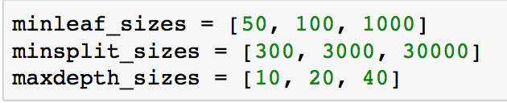

**

For each *min leaf size,* the smaller the *min split size*,the better the score. Moreover, higher *max depths* tend to give higher scores. Lastly, for each *min split size,* the smaller the *min leaf size* the better the score. Given the values above, the highest score was **0.485**.

Using information gained from the results above, we adjust the hyper-parameters to improve our model selection. The output below shows that the highest score from this round was **0.486** (a slight improvement)with a *max depth* of 30 and *min split size* of 300.

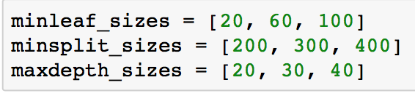



After settling on *max depth* and *min split size* as 20 and 300, respectively, we need to determine the optimal *min leaf size*. The additional tests show that the smaller *min leaf size* has performed better:

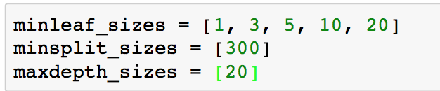



To conclude, the best result **0.486** (which outperforms the Logistic Regression Model) and log-loss **1.409**, is achieved using:

* *max depth size* = 20
* *min leaf size* = 5
* *min split size* = 300

Although, 1 and 3 perform slightly better than *min leaf size 5,* in order to reduce the complexity of the model, we used *min leaf size* 5 in our final model. The below figure summarizes the feature importance for our final decision tree models. The top three most important features are:

* **pct_SI** = % of Sinkers thrown by pitcher in previous year (Sinkers/Total Pitches)
* **pct_SL** = % of Sliders thrown by pitcher in previous year (Sliders/Total Pitches)
* **pct_FT** = % of 2-Seam Fastballs thrown by pitcher in previous year (2-Seam Fast/Total Pitches)

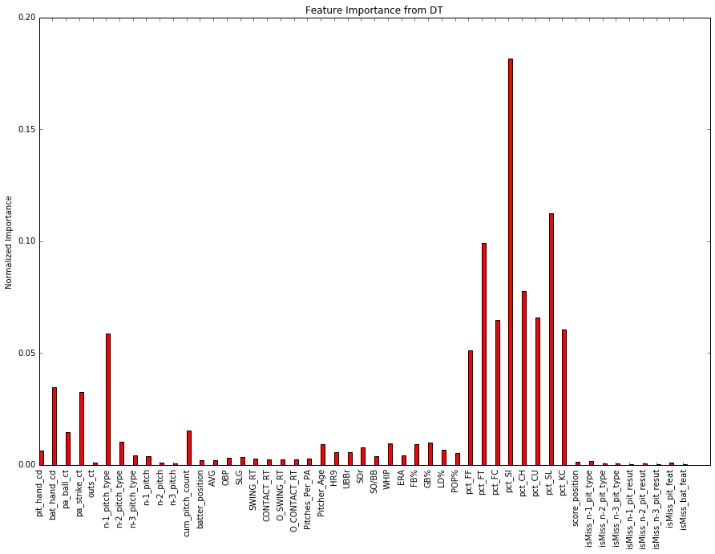

It should come as no surprise that the most important features are the pitcher’s distribution of pitch types from the previous season. For example, if a pitcher threw many sinkers in 2013, he will probably throw a lot of sinkers in 2014 as well. But why is the feature importance for pct_SI higher than the others? Sinkers are sometimes used to induce ground balls; perhaps the model predicts a higher likelihood of a sinker when there are runners on base and the pitcher wants to get a double play. Besides the pitch distribution features, the variable “n-1 pitch type” (the class of the previous pitch) appears to have some degree of predictive power. If a pitcher throws a 96 mph four-seam fastball (FF) on the previous pitch, he might be more inclined to throw in an 85 mph changeup (CH) to keep the batter off-balance.

Random Forests

We tried to do feature selection and used various subsets of features to run our models. Without exception, using all the features led to better performance than using a subset of the features. The output below indicates that both accuracy increased and log-loss decreased when we set max_features = None, rather than use the square root or log2 of the total number of features. Since our features have small correlation – most of the pairwise correlations are less than 0.02 – this could mean that we can improve our model by adding more useful features.

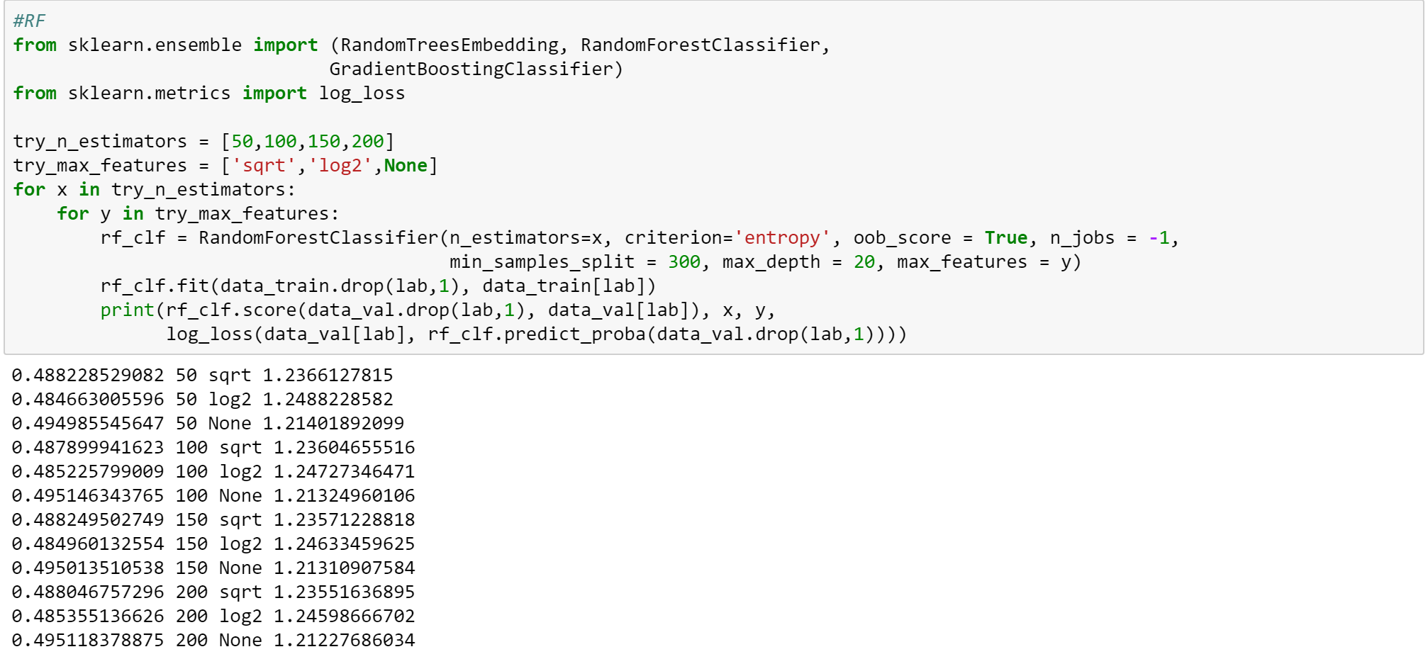

The best result we got is: log-loss decreased to 1.2015195355 and accuracy increased to 0.499554309564.

“Net Gain” or Expected Value of Predictions

In addition to calculating accuracy and log-loss, we also attempted to develop a metric more tailored to the needs of MLB teams, called “Net Gain”. At the end of the day, a baseball team wants to know whether the model will deliver positive results. One obstacle that arises with a multi-class target variable is that none of the classes have especially high probability, meaning that the exact type of the next pitch can be hard to predict. Furthermore, providing only a probability distribution for the next pitch (e.g. 25% chance of FF, 40% chance of CU, 35% chance of SI) is useless for a hitter in the batter’s box. Humans are notoriously bad at interpreting probability. A direct prediction (e.g. “the next pitch will be a CU”) is much more effective. However, this brings up the question: when should a prediction be given to the batter? It may be misleading to instruct the hitter to expect a CU when we are only 40% sure of the outcome.

With this problem in mind, we developed the idea of a “Prediction Certainty Threshold.” For example, at a threshold of 0.8, an MLB team would instruct the hitter to expect a certain type of pitch *only* when the team was at least 80% sure of its prediction. To calculate the “Prediction Certainty” for each pitch, we used the *predict_proba()* function to predict the probabilities of class membership. There were nine total classes (the main eight classes, plus an “Other” class). We then found the maximum probability in each row (ignoring the “Other” column) to derive the “prediction certainty” of a given pitch. We then added columns indicating: 1) the predicted outcome and 2) the actual pitch type. A sample of the subsequent data frame is illustrated below. The final column is the actual pitch type:

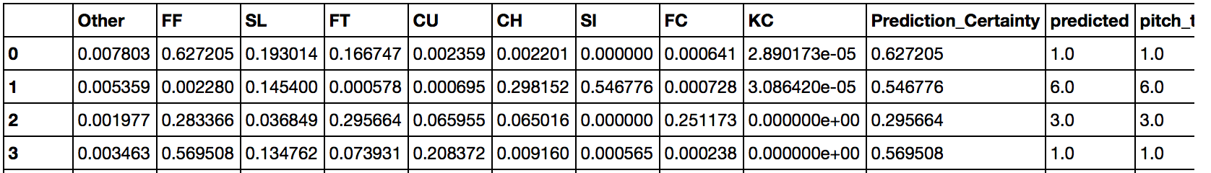

Once we created this data frame, we evaluated the accuracy of the model at different “prediction certainty” thresholds. For example, if we set the threshold = 0.8, we would collect the subset of records where the “prediction certainty” exceeded 0.8. We then calculated the percentage of records in this subset that were predicted correctly. We also counted the number of true positives (correct predictions), false positives (wrong predictions), and negatives (cases where no prediction was made). Example output from a random forests model is below. (Notice that we named the column “Precision” as opposed to “Accuracy”, because we are measuring the accuracy of *only those records that meet the 0.8 threshold*):

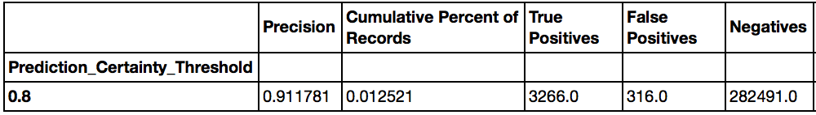

Essentially, the output tells us that for all records with “prediction certainty” above 0.8, the correct prediction was made 91% of the time. However, only 1.25% of the records in the validation set met this threshold, according to the “Cumulative Percent of Records” column above.

However, we still haven’t answered our initial question: will the model benefit or hurt an MLB team? To solve this problem, we used the Expected Value framework described in *Data Science for Business.[1]* This framework entails gathering a confusion matrix and multiplying it cell-wise against a cost-benefit matrix.Given a threshold of 0.8, the confusion matrix is:

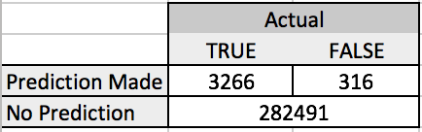

The cost-benefit matrix is more difficult to pin down. Let’s define the “net outcome” of a prediction as the change in batting average that occurs if a prediction is right (or wrong). If a prediction is correct, for example, the information might enable a .250 career hitter to perform at a .300 level. In this case, the “net outcome” would be 0.05. Conversely, if the prediction is incorrect, the .250 hitter might perform much worse, perhaps at a .150 level. The “net outcome” in this case would be -0.10.

We designated the “net outcome” of a prediction as 0.05 for a true positive, and -0.10 for a true negative. Our choices were somewhat arbitrary, but our basic intuition was that the loss from a false positive was far greater than the benefit of a true positive. We felt it would be safer to take a conservative/pessimistic view in our cost-benefit estimates. If we were to pursue this project in greater detail, we could try reaching out to current MLB players and ask for their opinion on the matter. In any event, this hypothesis yields the following cost-benefit matrix:

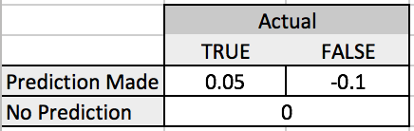

Using these two matrices, the “Expected Value” (or “Total Net Gain”) of making a prediction when the threshold is 0.8 is:

***Net Gain*** = True Positives (benefit of good prediction) + False Positives (cost of bad prediction)

3266(0.05) + 316(-0.10) = **131.7**

Because “Net Gain” is above 0, giving predictions to players when the prediction threshold is above 0.8 appears to add some value to an MLB team. One of the problems with “Net Gain”, however, is that the number itself does not convey significant meaning. Perhaps it would have been appropriate to divide Net Gain by 286,000 – the approximate number of records in the validation set. Net Gain divided by 286,000 could be construed as the “average gain in batting percentage per pitch”. In the example above, 131.7/286,000 = 0.00046, which is miniscule. For purposes of simplicity, let’s refrain from normalizing the values of Net Gain.

Our next question becomes: at what prediction threshold is “Net Gain” maximized? If we set our threshold too high, we will rarely issue any predictions, so the number of True Positives remains low. However, if we set our threshold too low, our precision will suffer. To find the optimal value of “Prediction Certainty Threshold”, we looked at a variety of thresholds from 0.4 to 1, using increments of 0.01. In the example below, “Net Gain” peaks at 366.4 when the threshold is 0.69:

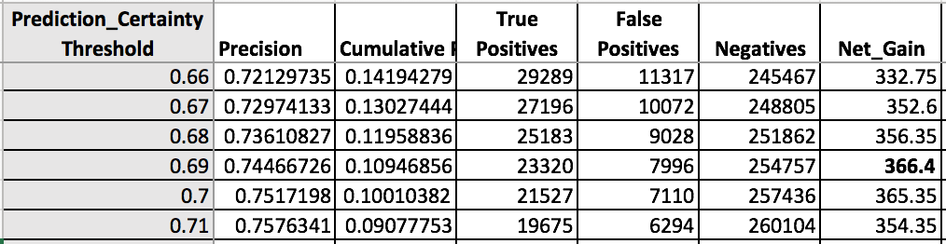

We then used Net Gain as a metric to evaluate the performance of our models, in addition to looking at accuracy and log-loss. We adopted this metric relatively late in the process, and so we only tested a handful of models. Regardless, the results for Net Gain roughly mirrored our earlier results for accuracy.

|  |  |  |  |  |  |
| --- | --- | --- | --- | --- | --- |
| **Model**  **Type** | **Parameters** | **Accuracy** | **Net_Gain**  **Maximum** | **Threshold** (where max. occurs) | **Coverage**  (where max. occurs) |
| DT | MinSplit=300, MaxDepth=20, MinLeaf=5 | 0.4868 | 355.15 | 0.70 | 0.105 |
| DT | MinSplit=300, MaxDepth=20, MinLeaf=50 | 0.4850 | 366.40 | 0.69 | 0.109 |
| RF | N_Est=100, MinSplit=300, MaxDepth=20 | 0.4951 | 360.60 | 0.64 | 0.096 |
| RF | N_Est=200, MinSplit=300, MaxDepth=20 | 0.4951 | 362.25 | 0.64 | 0.096 |
| RF | N_Est=100, MinSplit=100, MaxDepth=20 | 0.4995 | 467.10 | 0.64 | 0.113 |

According to the “Net Gain” metric, the final random forests model (with parameters n_estimators = 100, min_split_size = 100, and max_depth = 20) performed substantially better than the other models, with a Net Gain of 467.10. This result corroborated our earlier analysis, which found that this particular model had the highest accuracy (0.4995) and lowest log-loss (1.201). Generally speaking, if we were to give this model to an MLB team, we would likely advise them to only provide predictions to a batter if they were at least 64-70% sure of the next pitch type, given our cost-benefit estimates above. As illustrated in the appendix, the distribution of Net Gain plunges sharply downward as the probability threshold decreases. Therefore, we would probably recommend that MLB teams err on the side of caution when selecting a probability threshold, even if it means giving predictions for only 10% of all pitches (“coverage”). For a display of charts and graphs for the final RF model, please refer to the appendix.

Test Results

After testing a wide variety of models, we chose to apply a random forests algorithm with parameters n_estimators = 100, min_split_size = 100, and max_depth = 20. Our results were a mixed bag:

Test Results

|  |  |  |
| --- | --- | --- |
| **Accuracy** | **Log-Loss** | **Net Gain** |
| 0.4634 | 1.470 | 526.95 |

The maximum value for Net Gain increased to 526.95, corresponding to a probability certainty threshold of 0.60. While the result seems promising, it’s important to note that only 6.29% of records in our test set had a probability certainty over 0.6 (see appendix); because the model applies to fewer than 7% of total pitches, it would not be a very useful tool for MLB teams. Furthermore, if we were to normalize the Net Gain from our validation set (467.10) and the test set (526.95) by the number of records in the validation set (286,000) and the test set (739,000), respectively, the Net Gain for the validation set would look more impressive. Therefore, our test value for Net Gain is probably inferior to what we calculated earlier. Even more troubling, the accuracy plunged from 0.4995 to 0.4634, while log-loss increased from 1.201 to 1.470.

What accounts for the significant decrease in performance? It’s very possible that we over-fit the model in 2014 and 2015. When we employed random forests during the validation stage, we found that accuracy increased when we ignored the max_features parameter. While this decision helped boost performance for the particular validation set, it may have damaged the RF model’s ability to generalize to new data, since the individual decision trees in the forest were likely heavily correlated.

Deployment

The model would be used primarily to help MLB teams instruct hitters in the batters’ box about what pitch type to expect.

* The idea would be for someone in the team’s analytics department to input the values of the 20-30 most important features in our model before every pitch. While our dataset has around 50 features, many of the variables provide little predictive power.
* For each pitch, if the analyst saw that the model’s “prediction certainty” exceeded a particular threshold, say 0.7, the analyst would relay the model’s output to the manager, who in turn would reach out to the third- or first-base coach, who in turn would give signals to the batter.
* The system would be infinitely easier to operate if first- and third-base coaches were allowed to have earpieces, but in the MLB, coaches on the field must rely on hand signals.
* Regardless, given that the time between pitches is usually 20-30 seconds, there should be enough time for the model’s output to be communicated to the batter.

When using the model, an MLB team may want to consider collecting data on the model’s performance.

By collecting this data, a team could more accurately estimate the cost of a false positive and the benefit of a true positive prediction. In our model, we assumed that the benefit was 0.05 and the cost was -0.10, but these values were essentially guesswork.

Future Considerations

There are many ways in which we could have improved the model. First, we probably did not have enough features in our dataset. Our lack of meaningful features was probably exposed when we tried different options for the ‘max_features’ parameter in random forests, and found that performance was optimized when we set no limit. One category of features we wanted to obtain was a hitter’s batting average against each of the 8 pitch types; however, we could not find any online data for this metric. Clearly, if the batter is a good fastball hitter, the pitcher is more likely to throw slower pitch types. In hindsight, we should have collected the *percentage of pitch types seen by the batter in the previous season*. This set of 8 features (one for each pitch class) would have likely improved our model significantly. To build these features, we could have used a similar procedure as the one we used to create the 8 features indicating the pitcher’s pitch type distribution from the prior season. Furthermore, there are a few situational batting statistics from Baseball-Reference.com that may have been helpful, such as “first pitch swinging percentage”, “swinging percentage with a 3-0 count”, and so on.

Aside from feature selection, we could have re-considered the sizes of our training, validation, and test sets. The test set (2016) covered more than 33% of our data, while our validation set (20% of 2014-2015) covered only about 13% of the total data. Furthermore, it probably would have made more intuitive sense to order the training and validation sets by time, such that all records in the training set occurred before records in the validation set. Moving forward, we could flesh out the “Net Gain” concept a bit more so that it could be easier to explain to MLB teams. Finally, we could have tried gradient boosted trees as another ensemble technique. There is no guarantee that our test results would have improved, but it would have been interesting to compare random forests and gradient boosted trees.

Appendix – Results for Net Gain using Random Forests Models

Validation Set (n_estimators=100, min_split_size = 100, max_depth = 50):

|  |  |  |  |  |  |  |
| --- | --- | --- | --- | --- | --- | --- |
| **Prediction Certainty Threshold** | **Precision** | **Cumulative Percent of Records** | **True Positives** | **False Positives** | **Negatives** | **Net_Gain** |
| 0.4 | 0.556467888 | 0.656465308 | 104503 | 83294 | 98276 | -3104.25 |
| 0.41 | 0.564052372 | 0.625011798 | 100852 | 77947 | 107274 | -2752.1 |
| 0.42 | 0.572036092 | 0.594295862 | 97253 | 72759 | 116061 | -2413.25 |
| 0.43 | 0.579664376 | 0.564506262 | 93610 | 67880 | 124583 | -2107.5 |
| 0.44 | 0.587233654 | 0.535800303 | 90010 | 63268 | 132795 | -1826.3 |
| 0.45 | 0.59490546 | 0.506926554 | 86272 | 58746 | 141055 | -1561 |
| 0.46 | 0.602624522 | 0.478419844 | 82477 | 54386 | 149210 | -1314.75 |
| 0.47 | 0.611095994 | 0.449616007 | 78601 | 50022 | 157450 | -1072.15 |
| 0.48 | 0.619178559 | 0.422056608 | 74759 | 45980 | 165334 | -860.05 |
| 0.49 | 0.626528036 | 0.39604926 | 70985 | 42314 | 172774 | -682.15 |
| 0.5 | 0.634850617 | 0.370076868 | 67211 | 38658 | 180204 | -505.25 |
| 0.51 | 0.643148281 | 0.345621572 | 63590 | 35283 | 187200 | -348.8 |
| 0.52 | 0.650803461 | 0.322386244 | 60021 | 32205 | 193847 | -219.45 |
| 0.53 | 0.65880773 | 0.29934667 | 56417 | 29218 | 200438 | -100.95 |
| 0.54 | 0.667760676 | 0.27798499 | 53103 | 26421 | 206549 | 13.05 |
| 0.55 | 0.676845578 | 0.257448274 | 49849 | 23800 | 212424 | 112.45 |
| 0.56 | 0.68487099 | 0.238169978 | 46663 | 21471 | 217939 | 186.05 |
| 0.57 | 0.694083303 | 0.219129383 | 43510 | 19177 | 223386 | 257.8 |
| 0.58 | 0.702810337 | 0.201004639 | 40413 | 17089 | 228571 | 311.75 |
| 0.59 | 0.712801978 | 0.183764284 | 37472 | 15098 | 233503 | 363.8 |
| 0.6 | 0.722895588 | 0.167562126 | 34652 | 13283 | 238138 | 404.3 |
| 0.61 | 0.732924392 | 0.152153471 | 31902 | 11625 | 242546 | 432.6 |
| 0.62 | 0.743776748 | 0.138038193 | 29371 | 10118 | 246584 | 456.75 |
| 0.63 | 0.753643089 | 0.124737392 | 26893 | 8791 | 250389 | 465.55 |
| **0.64** | 0.763233789 | 0.112722976 | 24612 | 7635 | 253826 | **467.1** |
| 0.65 | 0.773279912 | 0.101204937 | 22388 | 6564 | 257121 | 463 |
| 0.66 | 0.782353396 | 0.090487393 | 20252 | 5634 | 260187 | 449.2 |
| 0.67 | 0.791904268 | 0.080916409 | 18331 | 4817 | 262925 | 434.85 |
| 0.68 | 0.803260395 | 0.072048044 | 16556 | 4055 | 265462 | 422.3 |
| 0.69 | 0.814197735 | 0.063571186 | 14807 | 3379 | 267887 | 402.45 |
| 0.7 | 0.823774571 | 0.056195447 | 13243 | 2833 | 269997 | 378.85 |
| 0.71 | 0.83391175 | 0.049354535 | 11774 | 2345 | 271954 | 354.2 |
| 0.72 | 0.841422899 | 0.043139339 | 10384 | 1957 | 273732 | 323.5 |
| 0.73 | 0.850729517 | 0.037375076 | 9096 | 1596 | 275381 | 295.2 |
| 0.74 | 0.860424981 | 0.032407812 | 7977 | 1294 | 276802 | 269.45 |
| 0.75 | 0.872686343 | 0.027950908 | 6978 | 1018 | 278077 | 247.1 |
| 0.76 | 0.88030215 | 0.024063788 | 6060 | 824 | 279189 | 220.6 |
| 0.77 | 0.887986464 | 0.020659063 | 5248 | 662 | 280163 | 196.2 |
| 0.78 | 0.895100751 | 0.017694784 | 4531 | 531 | 281011 | 173.45 |
| 0.79 | 0.901050175 | 0.014978694 | 3861 | 424 | 281788 | 150.65 |
| 0.8 | 0.911781128 | 0.01252128 | 3266 | 316 | 282491 | 131.7 |
| 0.81 | 0.918623884 | 0.010567233 | 2777 | 246 | 283050 | 114.25 |
| 0.82 | 0.918335296 | 0.008903322 | 2339 | 208 | 283526 | 96.15 |
| 0.83 | 0.924098672 | 0.007368749 | 1948 | 160 | 283965 | 81.4 |
| 0.84 | 0.925217391 | 0.006029929 | 1596 | 129 | 284348 | 66.9 |
| 0.85 | 0.936185642 | 0.004820448 | 1291 | 88 | 284694 | 55.75 |
| 0.86 | 0.942028986 | 0.003859155 | 1040 | 64 | 284969 | 45.6 |
| 0.87 | 0.946100917 | 0.003048173 | 825 | 47 | 285201 | 36.55 |
| 0.88 | 0.957251908 | 0.002289625 | 627 | 28 | 285418 | 28.55 |
| 0.89 | 0.962818004 | 0.001786257 | 492 | 19 | 285562 | 22.7 |
| 0.9 | 0.964010283 | 0.001359793 | 375 | 14 | 285684 | 17.35 |
| 0.91 | 0.958333333 | 0.001090631 | 299 | 13 | 285761 | 13.65 |
| 0.92 | 0.962184874 | 0.000831955 | 229 | 9 | 285835 | 10.55 |
| 0.93 | 0.97752809 | 0.000622219 | 174 | 4 | 285895 | 8.3 |
| 0.94 | 0.973913043 | 0.000401995 | 112 | 3 | 285958 | 5.3 |
| 0.95 | 0.983606557 | 0.000213232 | 60 | 1 | 286012 | 2.9 |

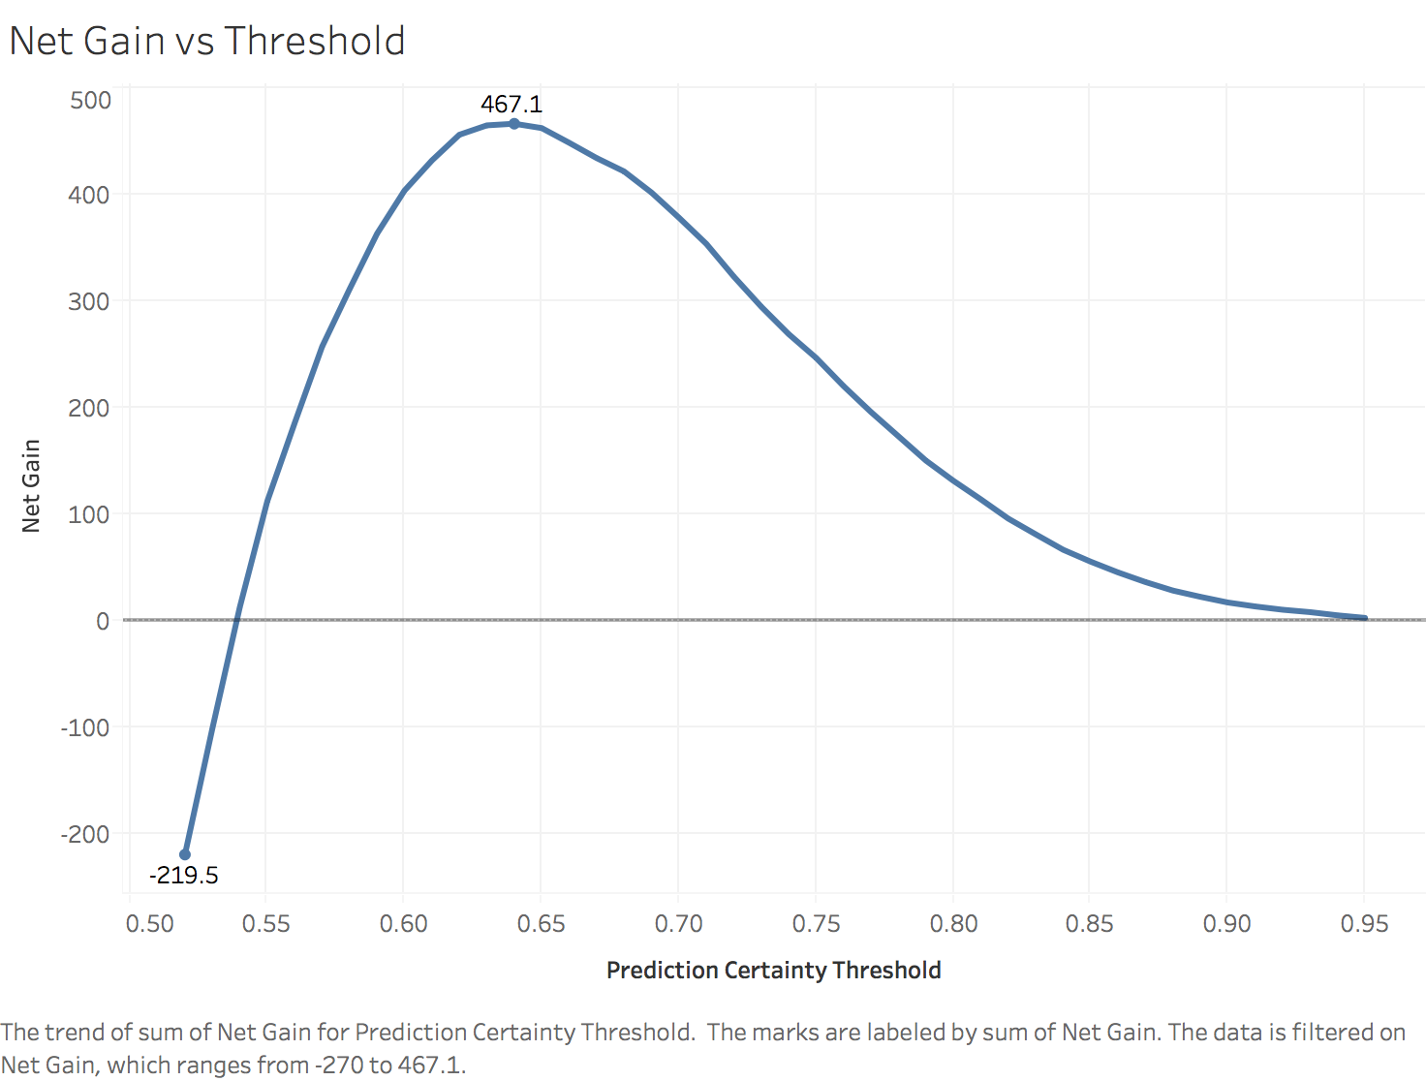

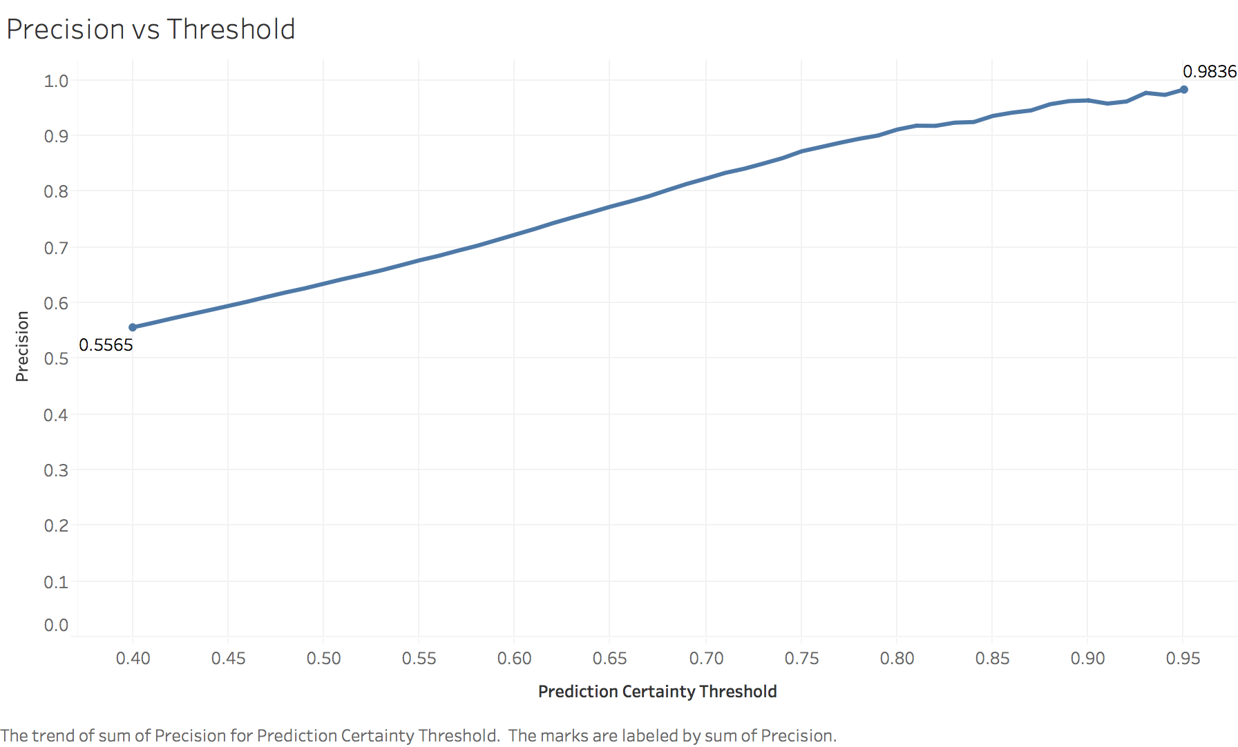

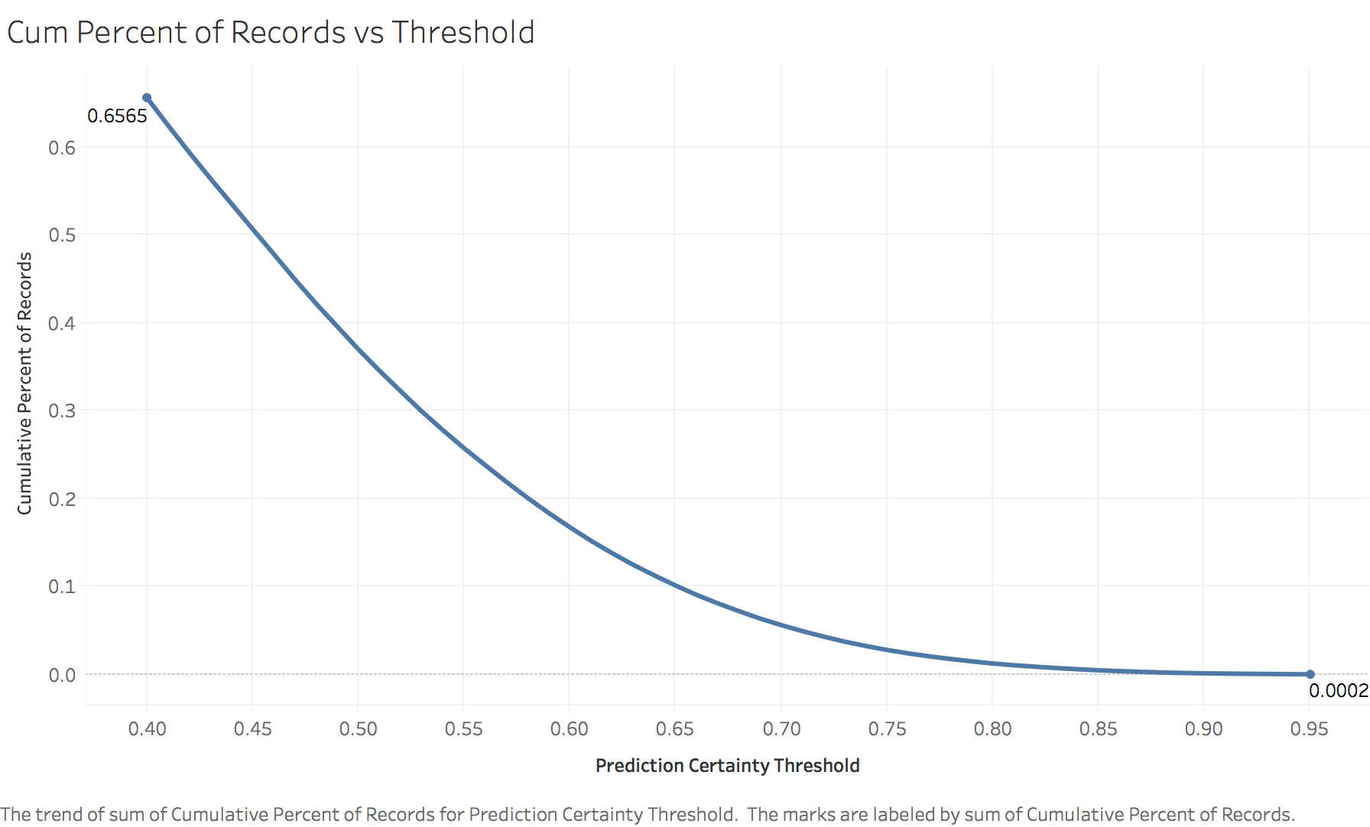

Test Set (n_estimators=100, min_split_size = 100, max_depth = 50):

|  |  |  |  |  |  |  |
| --- | --- | --- | --- | --- | --- | --- |
| **Prediction Certainty Threshold** | **Precision** | **Cumulative Percent of Records** | **True Positives** | **False Positives** | **Negatives** | **Net_Gain** |
| 0.4 | 0.540276552 | 0.573187842 | 228886 | 194760 | 315459 | -8031.7 |
| 0.41 | 0.546719543 | 0.540418479 | 218374 | 181052 | 339679 | -7186.5 |
| 0.42 | 0.552846676 | 0.508010364 | 207579 | 167894 | 363632 | -6410.45 |
| 0.43 | 0.559307759 | 0.477133831 | 197241 | 155411 | 386453 | -5679.05 |
| 0.44 | 0.566589005 | 0.445990759 | 186767 | 142867 | 409471 | -4948.35 |
| 0.45 | 0.574634451 | 0.415280643 | 176376 | 130560 | 432169 | -4237.2 |
| 0.46 | 0.581830922 | 0.384232281 | 165233 | 118755 | 455117 | -3613.85 |
| 0.47 | 0.590811543 | 0.352424892 | 153894 | 106585 | 478626 | -2963.8 |
| 0.48 | 0.600669215 | 0.320649975 | 142355 | 94639 | 502111 | -2346.15 |
| 0.49 | 0.611267658 | 0.290010215 | 131024 | 83324 | 524757 | -1781.2 |
| 0.5 | 0.620821133 | 0.261524411 | 120001 | 73293 | 545811 | -1329.25 |
| 0.51 | 0.630895472 | 0.234631074 | 109408 | 64009 | 565688 | -930.5 |
| 0.52 | 0.640853213 | 0.20944656 | 99206 | 55597 | 584302 | -599.4 |
| 0.53 | 0.651562136 | 0.185868043 | 89509 | 47867 | 601729 | -311.25 |
| 0.54 | 0.663090217 | 0.163932053 | 80342 | 40821 | 617942 | -65 |
| 0.55 | 0.674179305 | 0.14371571 | 71612 | 34609 | 632884 | 119.7 |
| 0.56 | 0.686130356 | 0.124591229 | 63183 | 28903 | 647019 | 268.85 |
| 0.57 | 0.698216631 | 0.107124157 | 55282 | 23894 | 659929 | 374.7 |
| 0.58 | 0.711844239 | 0.090962718 | 47858 | 19373 | 671874 | 455.6 |
| 0.59 | 0.726511231 | 0.076077147 | 40851 | 15378 | 682876 | 504.75 |
| 0.6 | 0.742254067 | 0.062881458 | 34497 | 11979 | 692629 | **526.95** |
| 0.61 | 0.756562369 | 0.051543421 | 28822 | 9274 | 701009 | 513.7 |
| 0.62 | 0.771977933 | 0.041938561 | 23929 | 7068 | 708108 | 489.65 |
| 0.63 | 0.785305607 | 0.034288768 | 19902 | 5441 | 713762 | 451 |
| 0.64 | 0.798588963 | 0.027998728 | 16526 | 4168 | 718411 | 409.5 |
| 0.65 | 0.808317625 | 0.02296832 | 13722 | 3254 | 722129 | 360.7 |
| 0.66 | 0.819772977 | 0.018475048 | 11194 | 2461 | 725450 | 313.6 |
| 0.67 | 0.830621572 | 0.014801686 | 9087 | 1853 | 728165 | 269.05 |
| 0.68 | 0.837591241 | 0.011862996 | 7344 | 1424 | 730337 | 224.8 |
| 0.69 | 0.847616345 | 0.009535858 | 5974 | 1074 | 732057 | 191.3 |
| 0.7 | 0.85796949 | 0.007716089 | 4893 | 810 | 733402 | 163.65 |
| 0.71 | 0.863259065 | 0.006193978 | 3952 | 626 | 734527 | 135 |
| 0.72 | 0.874496103 | 0.005034467 | 3254 | 467 | 735384 | 116 |
| 0.73 | 0.886965044 | 0.004141495 | 2715 | 346 | 736044 | 101.15 |
| 0.74 | 0.897547468 | 0.003420353 | 2269 | 259 | 736577 | 87.55 |
| 0.75 | 0.909219191 | 0.002876452 | 1933 | 193 | 736979 | 77.35 |
| 0.76 | 0.914728682 | 0.002443496 | 1652 | 154 | 737299 | 67.2 |
| 0.77 | 0.918128655 | 0.002082248 | 1413 | 126 | 737566 | 58.05 |
| 0.78 | 0.924662966 | 0.001706118 | 1166 | 95 | 737844 | 48.8 |
| 0.79 | 0.936613056 | 0.001430108 | 990 | 67 | 738048 | 42.8 |
| 0.8 | 0.939038687 | 0.001154099 | 801 | 52 | 738252 | 34.85 |
| 0.81 | 0.941176471 | 0.000897031 | 624 | 39 | 738442 | 27.3 |
| 0.82 | 0.948207171 | 0.0006792 | 476 | 26 | 738603 | 21.2 |
| 0.83 | 0.948320413 | 0.000523606 | 367 | 20 | 738718 | 16.35 |
| 0.84 | 0.953736655 | 0.00038019 | 268 | 13 | 738824 | 12.1 |
| 0.85 | 0.961352657 | 0.000280068 | 199 | 8 | 738898 | 9.15 |
| 0.86 | 0.968553459 | 0.000215125 | 154 | 5 | 738946 | 7.2 |
| 0.87 | 0.974137931 | 0.000156947 | 113 | 3 | 738989 | 5.35 |
| 0.88 | 0.987804878 | 0.000110945 | 81 | 1 | 739023 | 3.95 |
| 0.89 | 1 | 7.31E-05 | 54 | 0 | 739051 | 2.7 |
| 0.9 | 1 | 3.52E-05 | 26 | 0 | 739079 | 1.3 |

Insert Ali’s new graphs here.

1. Foster Provost and Tom Fawcett, *Data Science for Business: What You Need to Know About Data Mining and Data Analytic Thinking,* Chapter 7.